18 Image Compressors to Speed Up Your Website

[BY GRACE SMITHOCT 29, 2013](http://mashable.com/author/grace-smith/)

Whether it's JPEG, PNG, GIF or SVG, we've got you covered with this selection of 18 free, premium, online and desktop-based image compressors. All of them will help you compress your website's images, save bandwidth and improve your site's performance.

**1. [JPEGMini](http://www.jpegmini.com/" \t "_blank)**

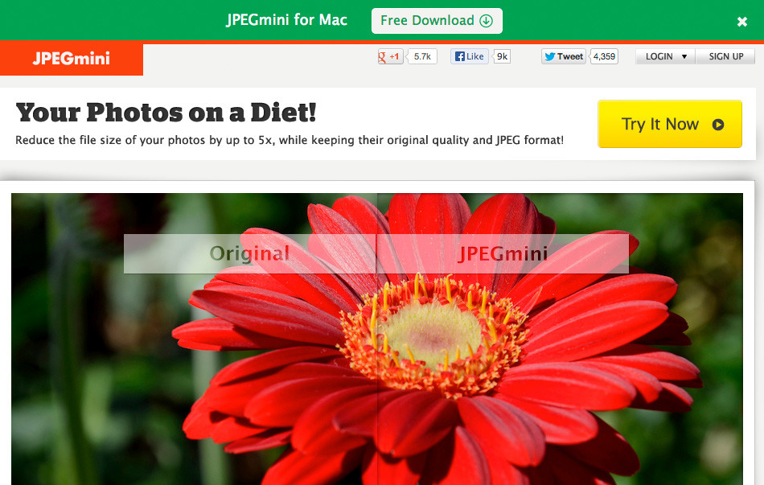

JPEGMini can help reduce the file size of your photos up to five times smaller, while keeping their original quality. It's available for Mac OS X and Windows as a desktop app, available as a free (limited) or a paid version.

To use JPEGMini, simply choose or drag folders to the app for it to optimize each image automatically. It also offers a server package, which enables you to lower your storage and bandwidth costs by reducing the load time of image-intensive web-pages.

**Price**: Free; Paid Version $19.99

**2. [Shrink O'Matic](http://toki-woki.net/p/Shrink-O-Matic/" \t "_blank)**

Shrink O'Matic is an Adobe AIR application to batch and resize images easily, handling JPGs, GIFs and PNGs. Drag and drop images into the app and they will be resized. You can customize the settings and choose the output sizes, rotation, name, location, format and watermark. It supports EXIF data so you won't lose any information once the images are processed.

**Price**: Free

**3. [Smush.it](http://www.smushit.com/ysmush.it/" \t "_blank)**

Smush.it is an online service from the Yahoo! Developer Network that optimizes your images. It uses lossless compression techniques, so the file size is reduced without changing the look or visual quality of the image.

The uploader supports JPEG, GIF and PNG files with maximum sizes of 1MB. The optimized results are available for download from a temporary URL, which is valid for up to 30 minutes afterwards.

**Price**: Free (online uploader)

**4. [RIOT](http://luci.criosweb.ro/riot/" \t "_blank)**

RIOT (Radical Image Optimization Tool) is a free program to optimize images for the web efficiently. It includes an easy-to-use interface to compare the original with the optimized image in real time, so you can instantly see the resulting file size.

The program is lightweight, fast and boasts powerful features for more advanced users. It supports various formats and features automatic optimization that selects the most suitable format and parameters.

**Price**: Free

**5. [Image Optimizer](http://www.imageoptimizer.net/Pages/Home.aspx" \t "_blank)**

Image Optimizer lets you resize, compress and optimize your images, and it's available as either a free online service, a free desktop application or as a paid upgrade to remove the promo text at the bottom of optimized images.

It's simple to use and allows you to choose the resulting optimization quality, max width and max height. You can compress images in bulk and view the progress of the optimization.

**Price**: Free; ~$50 to remove promo text

**6. [PNG Gauntlet](http://pnggauntlet.com/" \t "_blank)**

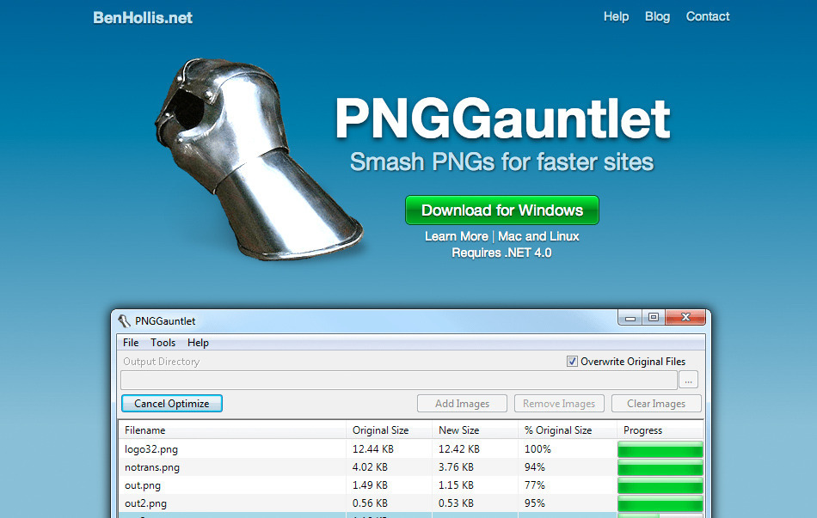

PNG Gauntlet lets you optimize PNG files and is available for Windows. It combines [PNGOUT](http://advsys.net/ken/util/pngout.htm" \t "_blank),[OptiPNG](http://optipng.sourceforge.net/" \t "_blank) and [DeflOpt](http://www.walbeehm.com/download/" \t "_blank) to create the smallest file sizes possible, with no reduction in image quality.

The program converts JPG, GIF, TIFF and BMP files to PNG, and gives individual progress bars for each file, highlighting the file that is currently compressing, and a status bar to keep track of the total bytes saved.

**Price**: Free

**7. [CompressNow](http://compressnow.com/" \t "_blank)**

CompressNow is a free online service that lets you upload images from your computer, choose a compression percentage and download the optimized image. It supports GIF, JPG and PNG formats.

The service also allows the drag and drop of multiple images from you computer, with a max upload of 10 images and a max individual file size of 3MB.

**Price**: Free (online uploader)

**8. [Trimage](http://trimage.org/" \t "_blank)**

Trimage is a cross-platform tool for optimizing PNG and JPG files using OptiPNG, PNGCrush, AdvPNG or JPEGOptim, depending on the file type. Images are losslessly compressed on the highest available compression levels, with EXIF and other metadata removed.

Trimage is available to download for various platforms including Mac OS X, Windows and Linux.

**Price**: Free

**SEE ALSO: [17 Sites for Web Design Inspiration](http://mashable.com/2013/10/09/web-design-inspiration-2/)**

**9. [PunyPNG](http://www.punypng.com/" \t "_blank)**

PunyPNG is image compression tool for designers and developers that dramatically reduces the size of your images without any loss in quality. It first analyzes the content of your image and figures out the best web optimization technique and format to use. It supports the most popular formats and, depending on the file, PunyPNG will decide how to convert your image to ensure the best possible results.

**Price**: Free trial for higher compression and lossy optimizations; Basic plan is $3 per month (first month free) or $30 per year; Pro plan is $6 per month (first month free) or $65 per year; Team plan is $12 per month (first month free) or $125 per year.

**10. [PNG Optimizer](http://psydk.org/PngOptimizer" \t "_blank)**

PNG Optimizer cleans your PNG files of useless or wrong information, reduces their weight and converts PNG into other lossless image formats such as BMP, GIF OR TGA. It also supports animated PNGs and is available on Windows XP, Vista and 7. You can also easily create PNG screenshots within a simple, productive user interface.

**Price**: Free

**11. [Shrink Pictures](http://www.shrinkpictures.com/" \t "_blank)**

Shrink Pictures allows you to resize pictures and choose the level of compression applied, and it supports JPG, GIF and PNG. You can select the maximum image dimension, apply special effects, and download the optimized images.

Shrink Pictures ensures privacy by using an automated script to remove any processed images from the server.

**Price**: Free (online uploader)

**12. [ImageOptim](http://imageoptim.com/" \t "_blank)**

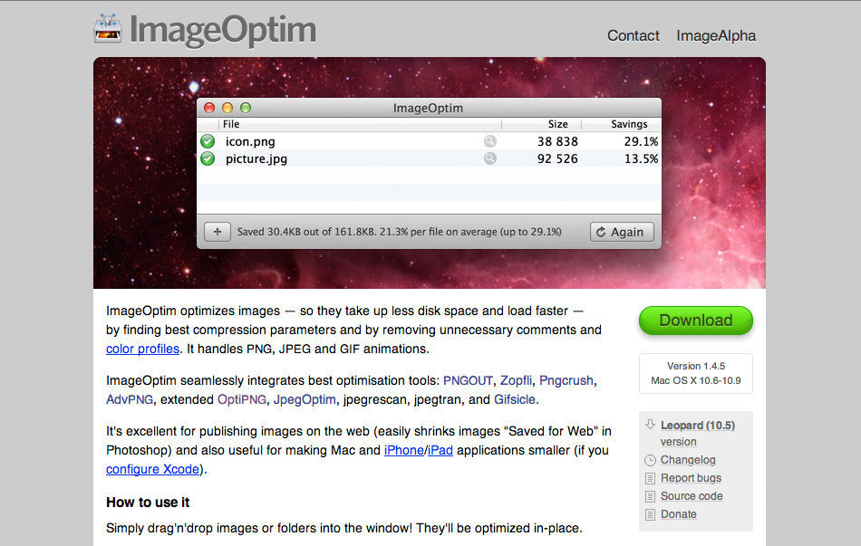

ImageOptim optimizes images by finding the best compression parameters and removing unnecessary comments and color profiles. It handles PNG, JPEG, and GIF formats.

It's also easy to use; just drag and drop images or folders into the window and they will be optimized in-place. You can also drop files on ImageOptim's dock icon, use the Services menu in Finder (on Macs), or launch it from a shell script.

**Price**: Free

**13. [Blubox](http://www.blubox.com/" \t "_blank)**

BluBox is a Windows-based photo compressor that uses advanced image algorithms to compress your images by up to 90%, while retaining the original resolution and quality for printing and viewing. It supports more than 60 popular image formats and can even preview regular ZIP archives.

Blubox includes Preview and Slideshow features, so there's no need to extract your pictures to view them.

**Price**: Free version (ad-supported); full license ~$35

**14. [Image Optimizer](http://tools.dynamicdrive.com/imageoptimizer/" \t "_blank)**

The Online Image Optimizer from Dynamic Drive lets you easily optimize GIFs, JPGs and PNGs so they load as fast as possible. The images can be converted from one file type to another, with an upload size limit of 2.86MB.

You can enter the URL of the image or upload it from your computers, choose your image conversion, optimize it and download the results.

**Price**: Free (online uploader)

**15. [JPEG Optimizer](http://jpeg-optimizer.com/" \t "_blank)**

JPEG Optimizer is a free online tool to resize and compress your photos and images in order to reduce bandwidth and use them on blogs, forums and emails.

Simply upload the image you wish to optimize, choose a compression level (from 0-99, with the default at 65), pick your required image width (if you would like the image resized) and click "Optimize Photo."

**Price**: Free (online uploader)

**SEE ALSO: [20 Tools to Showcase Your Portfolio](http://mashable.com/2013/09/17/online-portfolio/)**

**16. [JPEG Reducer](http://www.jpegreducer.com/" \t "_blank)**

JPEG Reducer shrinks the sizes of your images and photos to make them load faster, and works by using lossy compression. However, you may not even notice that any changes have been made.

Just upload your image or enter its URL and press "Reduce It." You can then view the compressed images and thumbnails, and right-click the image to save it.

**Price**: Free (online uploader)

**17. [FILEMinimizer Pictures](http://www.balesio.com/fileminimizerpictures/eng/index.php" \t "_blank)**

FILEMinimizer Pictures allows you to reduce the size of you images and photos by up to 98% and supports a variety of formats, including JPG, BMP, GIF, TIFF, PNG and EMF. You can optimize your images and send them via email, or upload them to Facebook. Four different compression levels are available, and you can choose to process a batch and decide how the EXIF data is handled.

**Price**: Free

**18. [TinyPNG](http://tinypng.org/" \t "_blank)**

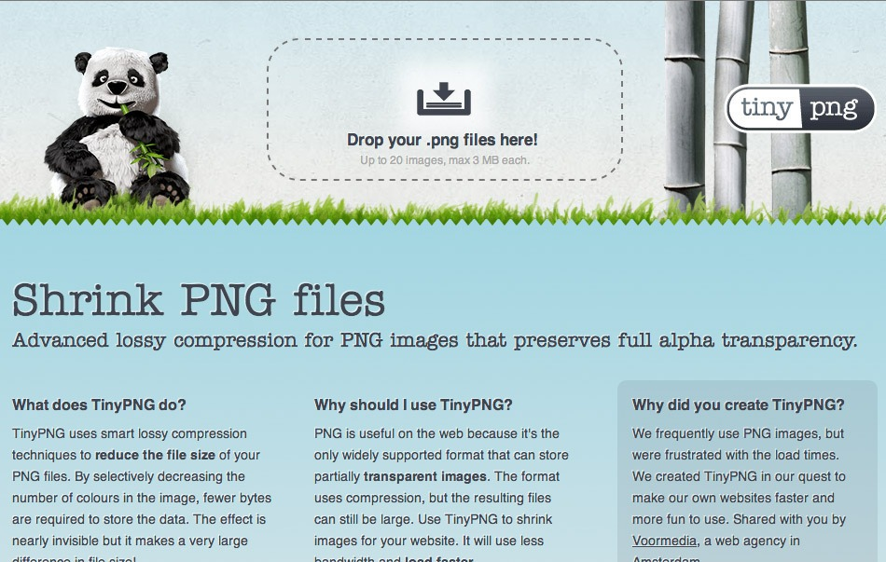

TinyPNG enables advanced lossy compression for PNG images. It preserves full alpha transparency and reduces the file size by selectively decreasing the number of colors and bytes in the image.

The effect is nearly invisible, but it makes a large difference in file size. It takes 24-bit PNG files and converts them to much smaller 8-bit indexed color images, with all unnecessary metadata stripped as well.

**Price**: Free (online uploader)